COAL Lab 02 Assignment:

# Name: Owais Ali Khan

# Section: 3-F

# Roll no: 21K-3298

Question # 01:

TITLE Question 1

INCLUDE Irvine32.inc

.DATA

A1 equ 47d

A2 equ 39d

A3 equ 60d

A4 equ 85d

A5 equ 64d

A6 equ 54o

A7 equ 0Ah

.CODE

main PROC

mov eax, A1

add eax, A2

add eax, A3

add eax, A4

add eax, A5

add eax, A6

sub eax, A7

call DumpRegs

exit

main ENDP

END main

;47 + 39 + 60 + 85 + 64 + 54o - 0Ah

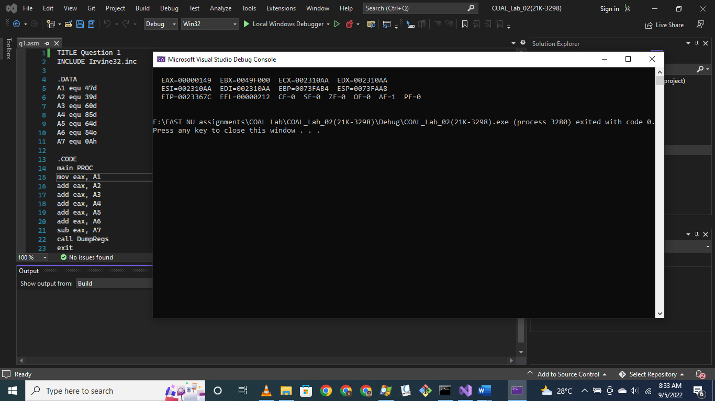

Question # 02:

TITLE Question 2

INCLUDE Irvine32.inc

.DATA

A1 equ 30

A2 equ 9

A3 equ 186

A4 equ 150

.CODE

main PROC

mov eax, A1

sub eax, A2

add eax, A3

sub eax, A4

call DumpRegs

exit

main ENDP

END main

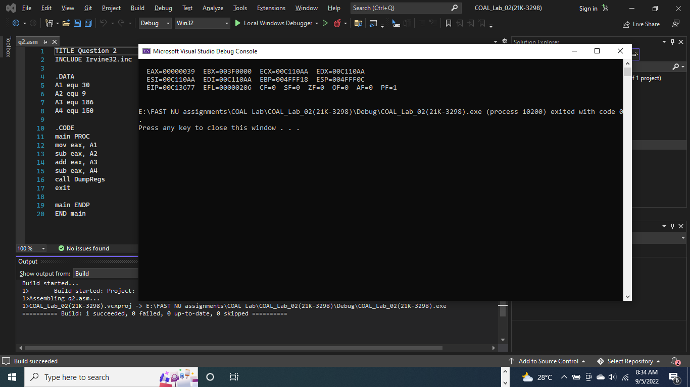

Question # 03:

TITLE Question 3

INCLUDE Irvine32.inc

.CODE

main PROC

mov eax, 101110b

add eax, 50Ah

add eax, 6710d

add eax, 1010001b

add eax, "F"

call DumpRegs

exit

main ENDP

END main

;101110 + 50Ah + 6710d + 1010001 + F

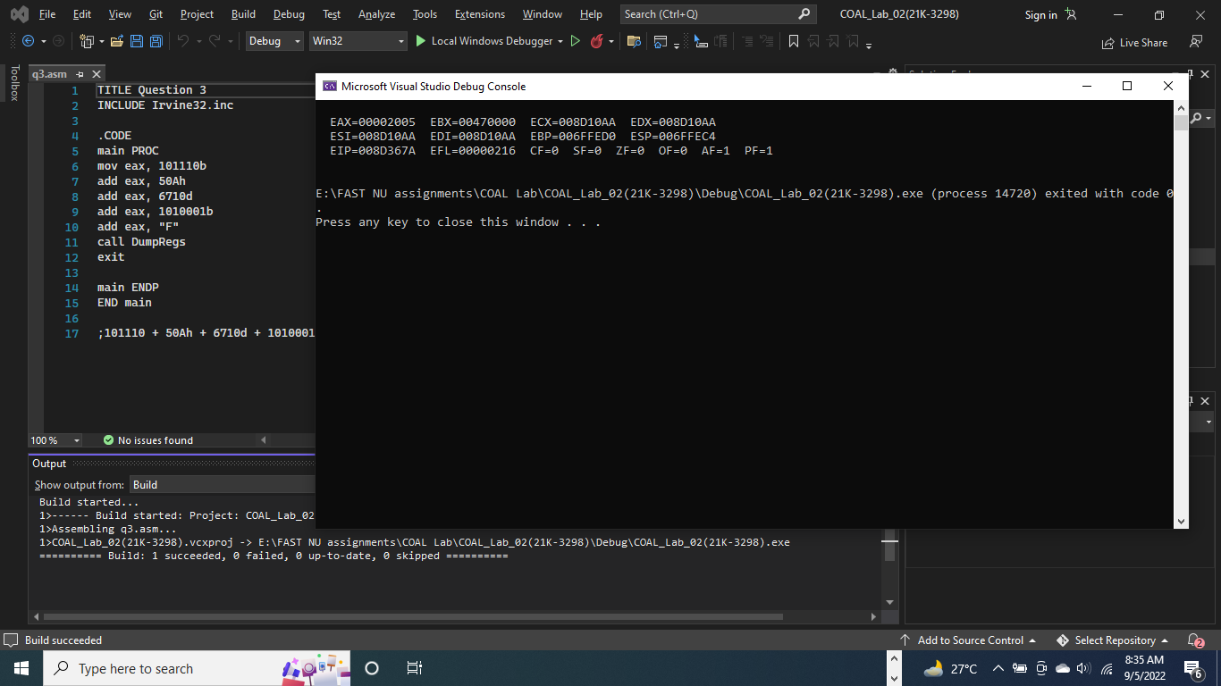

Question # 04:

TITLE Question 4

INCLUDE Irvine32.inc

.CODE

main PROC

mov eax, 10001101b

sub eax, 0D83h

add eax, 385d

add eax, 10d

add eax, 1111101b

sub eax, "E"

add eax, "F"

call DumpRegs

exit

main ENDP

END main

;10001101 – D83h + 385 + 10 + 1111101 – E + F

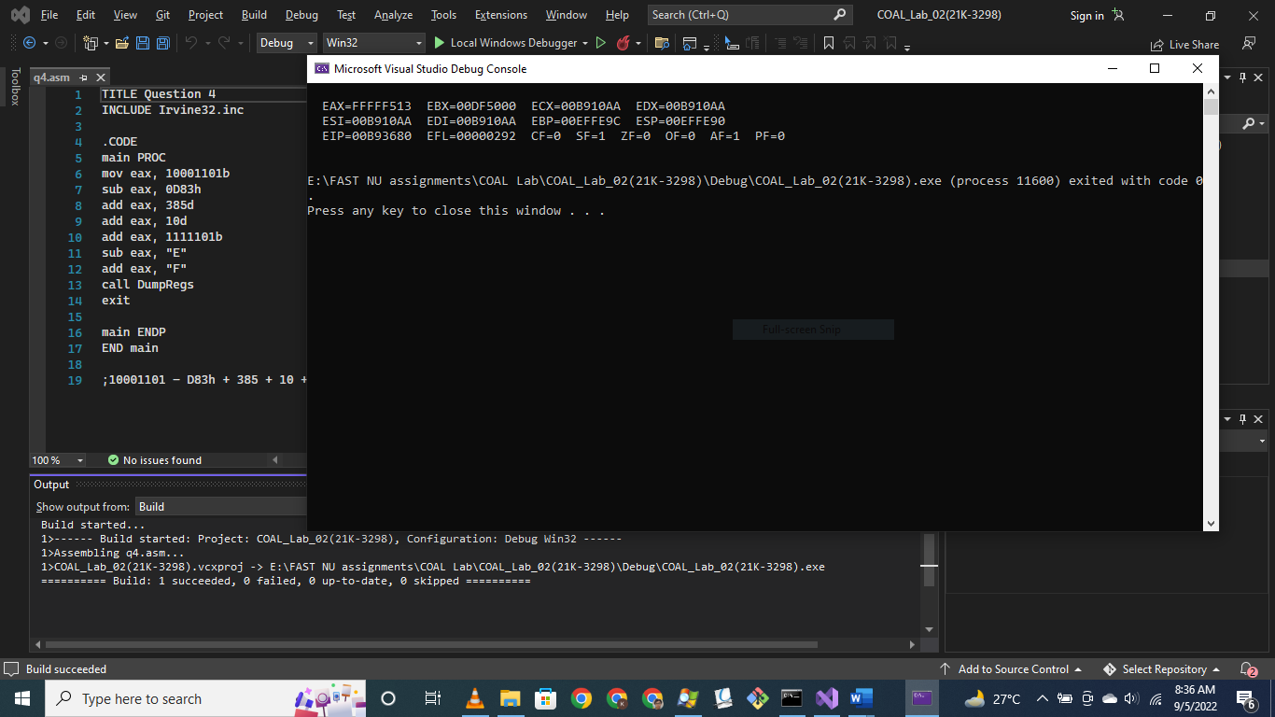

Question # 05:

TITLE Question 5

INCLUDE Irvine32.inc

.code

main PROC

mov eax, 0Ah

mov ebx, 65o

mov ecx, 73d

mov edx, 0

sub edx, eax

mov eax, edx

add eax, 1

add eax, ebx

;add eax, edx

sub eax, ecx

add eax, 0Ah

sub eax, ebx

add eax, ecx

mov edx, eax

call DumpRegs

exit

main ENDP

END main

;edx = ­-eax + 1 + ebx + edx – ecx + 0Ah - 65o + 73d

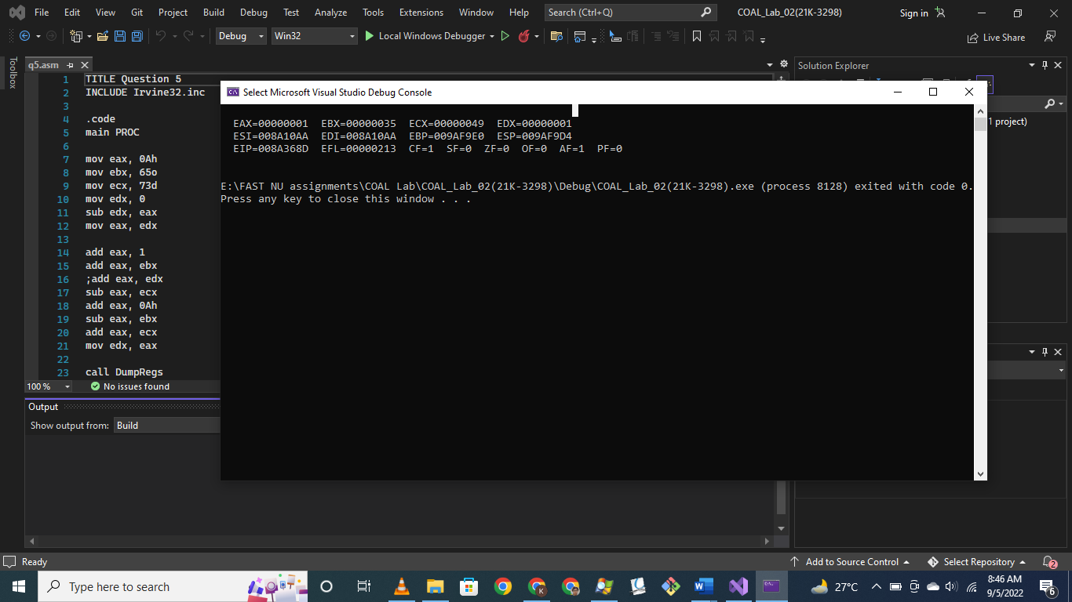

Question # 06:

TITLE Question 6

INCLUDE Irvine32.inc

.code

main PROC

mov eax, 65o

mov edx, 0

sub edx, eax

mov eax, edx

add eax, 5ADh

add eax, 65o

add eax, 65d

sub eax, 11110111b

add eax, 150

call DumpRegs

exit

main ENDP

END main

;eax = 5ADh – eax + 65o + 65d – 11110111 + 150

